DTH
8

ANNUAL FUNDRAISER
INNER

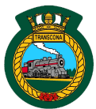

Proceedstosupportthe Royal CanadianSea Cadet Corps -#350TRANSCONA

Friday, March 1, 2019
6:30 - 9:00 pm

Transcona Legion
117 Regent Avenue East

$10.00 in advance
($15.00 at the door)

Silent Auction 50/50 Draw
Tickets available at the Transcona Legion, 117 Regent Avenue East

