ANNOUNCING A LIVE PERFORMANCE

FRIDAY -September 27th at our BRANCH

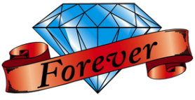
Renown Neil Diamond Impersonator
Jason Scott will be performing hits of
Neil Diamond.

Come join us in a great evening of entertainment.

Tickets can be purchased at our Bar for $25.00.

The show is open to members and the public.

